At-Risk Sea Turtles

Social Studies Benchmarks:

Grade: 3

SS.3.E.1.1 Give examples of how scarcity results in trade.

SS.2.E.1.1 Recognize that people make choices because of limited resources.

SS.3.A.1.1 Analyze primary and secondary sources.

SS.3.A.1.2 Utilize technology resources to gather information from primary and secondary sources.

Economic Concepts for Review:

Scarcity – Not having enough of a resource to meet the wants and needs of consumers

Limited Resources – resources that exist in a specific amount

English/Language Arts Standards:
LAFS.3.RI.1.1 Ask and answer questions to demonstrate understanding of a text, referring explicitly to the text as the basis for the answers.
LAFS.3.RI.3.7 Use information gained from illustrations (e.g., maps, photographs) and the words in a text to demonstrate understanding of the text (e.g., where, when, why, and how key events occur).
LAFS.3.W.3.8 Recall information from experiences or gather information from print and digital sources; take brief notes on sources and sort evidence into provided categories.
LAFS.3.SL.1.1 Engage effectively in a range of collaborative discussions (one-on-one, in groups, and teacher-led) with diverse partners on grade 4 topics and texts, building on others’ ideas and expressing their own clearly.
- Come to discussions prepared, having read or studied required material; explicitly draw on that preparation and other information known about the topic to explore ideas under discussion.
- Follow agreed-upon rules for discussions and carry out assigned roles.
- Pose and respond to specific questions to clarify or follow up on information, and make comments that contribute to the discussion and link to the remarks of others.
- Review the key ideas expressed and explain their own ideas and understanding in light of the discussion.

For this decision-making lesson, students will discuss criteria for choosing the species of sea turtle that is in most need of funding to protect it’s endangered status. Students conduct research using information from the National Oceanic and Atmospheric Administration (NOAA) and other web-based resources. Using this information, students will rank their choices and explain how they reached their decisions.

Problem
Which sea turtle is in the greatest need of protection?

Alternatives
Green Sea Turtle, Leatherback Sea Turtle, Loggerhead Sea Turtle, Hawksbill Sea Turtle

Criteria
To what extent are they endangered, who are their predators, how long do they live, why are they in trouble?

Decision
Which sea turtle presents the greatest need? How did you make that decision?

- Read the letter from the The Lorax and National Oceanic and Atmospheric Administration and discuss the decision that the organization wants the students to make (which species of sea turtle presents the greatest need for assistance). What is a scarce resource that is forcing NOAA to reduce its focus to only one type of turtle (money).
- What makes some sea turtles a limited resource? Why are sea turtles worth protecting? What environmental hazards are a danger to sea turtles?
- Explore The Faunalytics website at https://faunalytics.org/endangered/?gclid=EAIaIQobChMIxP-ire7D1wIVC1gNCh2d4wDfEAAYASAAEgLKsPD_BwE (note: this link may have to be copied and pasted into a browser due to its htpps address).
- Read the information beginning with Endangered Species: Once They’re Gone, There’s No Bringing Them Back. Discuss how this impacts our lives (changing habitats, food chains, missing the beauty of animals no longer in existence, etc.)
- Explore the information about the threats to sea turtles at http://www.seeturtles.org/sea-turtles-threats?gclid=EAIaIQobChMIzLOM-OTF1wIVnVcNCh0_ZABmEAAYASAAEgIr2_D_BwE .
- Discuss how each of these threats are man-made.
- Scroll down to find out the extent to which seven sea turtles are at-risk (The explanation of the scale is below the list of turtles. In a later link a chart that is kid-friendly will supply this information for each sea turtle).
- View the video at https://www.youtube.com/watch?v=w82xpBR_Z4A
- What could happen to keep these babies from making it to the water? What dangers are in the environment (predators, people, trash on the beach, light that confuses the turtles, etc.)?
- Project the pictures of four different sea turtles: Green Sea Turtle, Leatherback Sea Turtle, Loggerhead Sea Turtle, Hawksbill Sea Turtle (pictures are located at the bottom of this lesson plan).
- Provide students with the decision-making matrix. Review the alternatives and criteria related to the turtles. (Use the note-taking tool if students need additional space for notes. Notes can be summarized and transferred to the matrix later).
- Use the following link to research the extent to which each turtle is endangered: https://www.worldwildlife.org/pages/infographic-sea-turtles
- View the chart with students. Discuss the categories of being at-risk from least to most (vulnerable, endangered, critically endangered). Refer back to the website that explained what the category ‘data deficient’ means.
- Model reading the chart on Green Sea Turtles. To what extent are these turtles at-risk (endangered)? Model entering this information into the matrix.
- Continue reading the chart and discussing each of the other three types of turtles.
- Use the following link to go to the NOAA website: https://www.fisheries.noaa.gov/sea-turtles
- Click on the links for each of the four sea turtles. Each article provides information related predators, life span, and why are they at-risk. Gather relevant information and write it on the matrix. (These articles can be downloaded as PDFs to allow students to annotate the texts)
- After all information has been gathered, use the matrix to start a discussion on Green Sea Turtles. What notes did you take for each of the criteria? Would this be a good choice for NOAA to offer support? Why or why not?
- Repeat this process for the other turtles.
- Before breaking into teams, ask questions to guide decision-making. Is endangered status more important that how long turtles live? Can communities do something about why turtles are in trouble rather than NOAA having to step in?
- In teams the students will work together to evaluate the completed matrix and make a decision regarding which sea turtle should be supported by NOAA.
- Teams will then present their findings to the class, giving the reasons why ranked the choices as they did and the procedure of how they got to that decision. Prompt students to think about each step of their decision-making processes. What did they do first? After that?
- Students write a letter to The Lorax and NOAA reporting:
- how they ranked each park choice
- the process they used for making their choices and
- why NOAA should support this particular species of sea turtle.

A frame can also be used:
Date:
Dear Lorax and NOAA,
Our team has reviewed information on the four species of sea turtles you provided and is suggesting the following sea turtle for further support. We have ranked the species of sea turtles in order beginning with our top choice.
Top Choice:
Alternate Choice #1:
Alternate Choice #2:
Alternate Choice #3:
Our step-by-step procedure for ranking the choices in this way was:

Thank you for the opportunity to assist you with this project!
Sincerely,

Extension/ideas:
- Create a presentation for NOAA that outlines why a particular sea turtle should be further supported.
- Read more about endangered species at ReadWorks:
  - Endangered Species (text set) https://www.readworks.org/article/Endangered-Species/3077e686-4015-43f3-80c2-ed39ae8b0dce#!articleTab:content/contentSection:d8ae9323-b2ff-4b73-bbbb-10b9a3af572d/
  - They’re Back! https://www.readworks.org/article/Theyre-Back!/4570c345-4dd0-4b2d-b687-bf9fb6ee1aed#!articleTab:content/

Differentiation:
- Reduce alternatives and/or criteria.
  - Create a new letter from NOAA asking students to reconsider their choices based on different alternatives/criteria
- Increase alternatives and/or criteria.
  - Same as above
- Provide note-taking tools with some of the information from Reading Wonders, videos, and/or web articles already filled in.

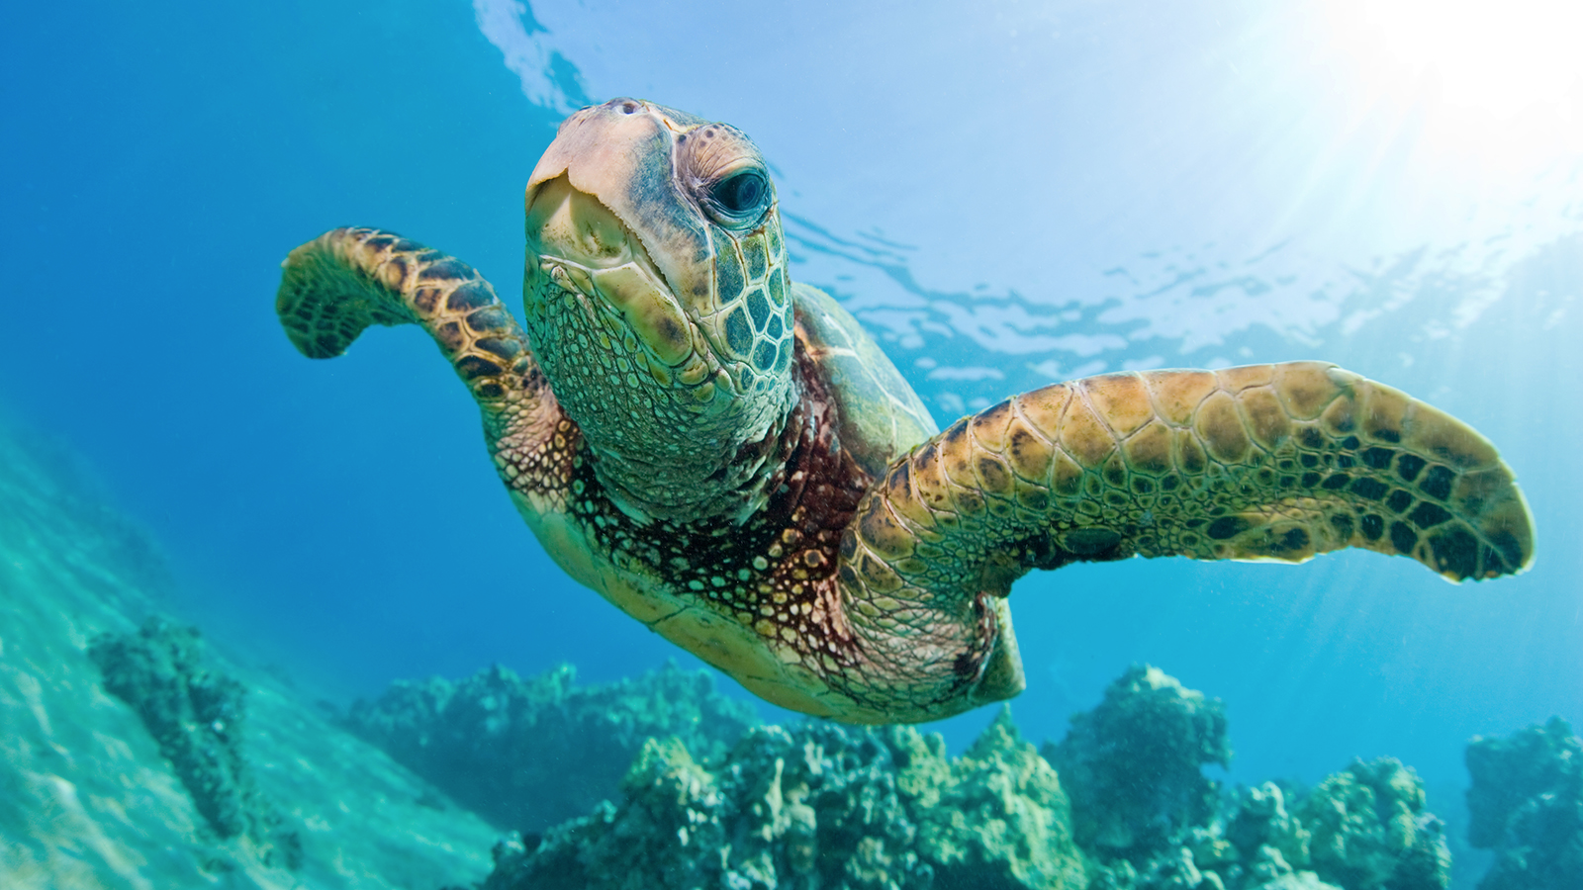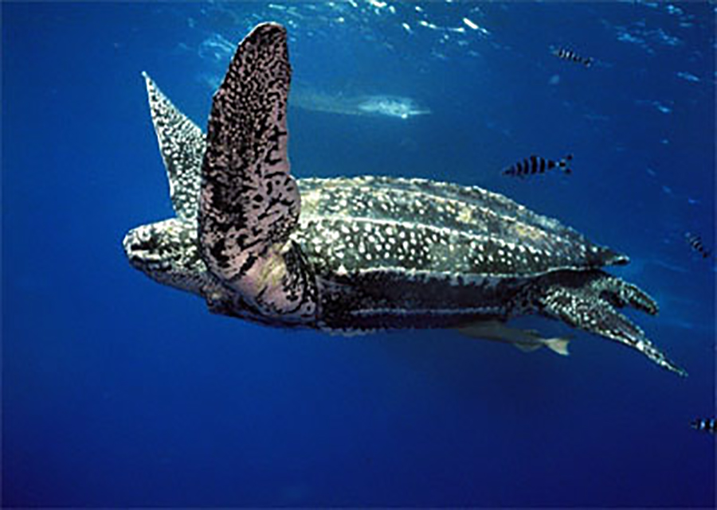
Green Sea Turtle Leatherback Sea Turtle

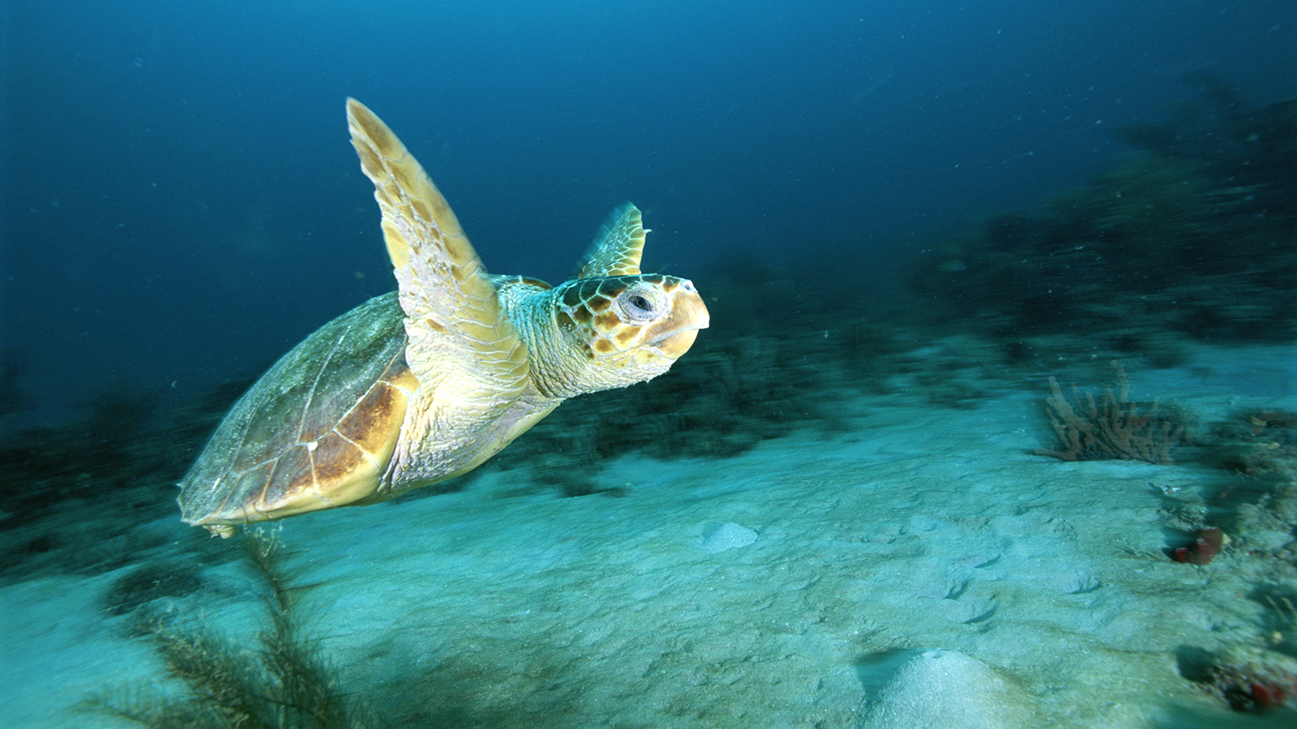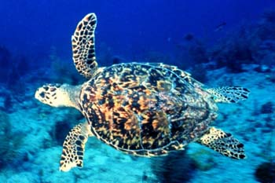
Loggerhead Sea Turtle Yosemite National Park

