Gardening

Literature:
- How Groundhog’s Garden Grew Lynne Cherry
  - Why did Groundhog to into his neighbor’s garden? Was this a good decision? Why or why not?
  - What does Squirrel offer to do?
  - What is the first thing they need to plant the garden?
  - How do they get the seeds?
  - Why did Squirrel save a few potatoes?
  - What does it mean that the potatoes were sprouting? How did Squirrel prepare the potatoes for planting?
  - What steps did Squirrel and Groundhog take in planting the garden?
  - Describe the ecosystem of the garden. What roles do the living and nonliving parts of the ecosystem play in the growth of the garden?
  - What resources did Squirrel and Groundhog use in planting and harvesting the garden?
  - What lessons did Groundhog learn?
- Tops and Bottoms Janet Stevens
  - What resources does Bear have?
  - What resources does Hare have?
  - We can call Hare an entrepreneur? What does that mean?
  - Does Hare’s original deal with Bear sound like a good deal for both parties? Why or why not?
  - What resources do Hare and his family need to grow the garden?
  - How does Hare continue to outwit Bear?
  - What are the different parts of Hare’s garden ecosystem?
  - What lessons did both Bear and Hare learn?
- Jack’s Garden Henry Cole
  - What are the tools Jack needed to plant his garden?
  - What are different parts of the ecosystem of Jack’s garden?
  - What do seeds need in order to grow a plant, or germinate?
  - Which way to leaves grow? Why do they do this?
  - Why types of plants grew in Jack’s garden? How could we categorize these plants?
  - How does this garden ecosystem work?
- Carl’s Community Garden ReadWorks
- Playtime in the Snow ReadWorks

Informational Texts:
- Kids Dig In ReadWorks
- Enjoy your Garden Ecosystem
- Florida Xeriscaping
- Good Reasons for Community Gardens
- Benefits of Gardening for Children

Images:

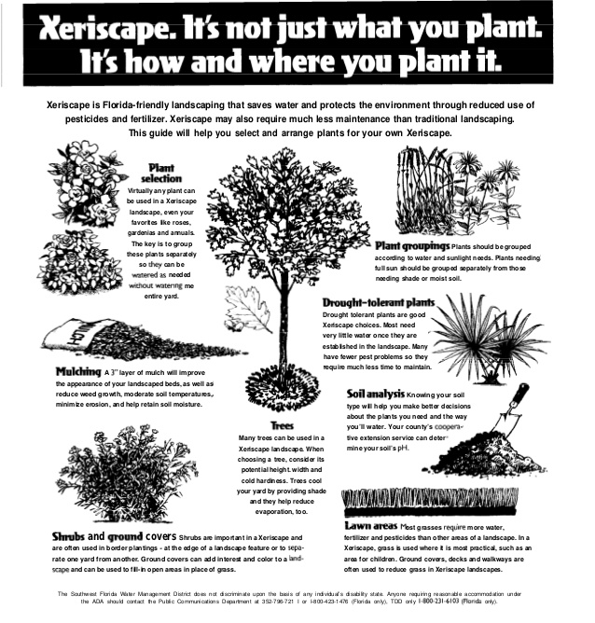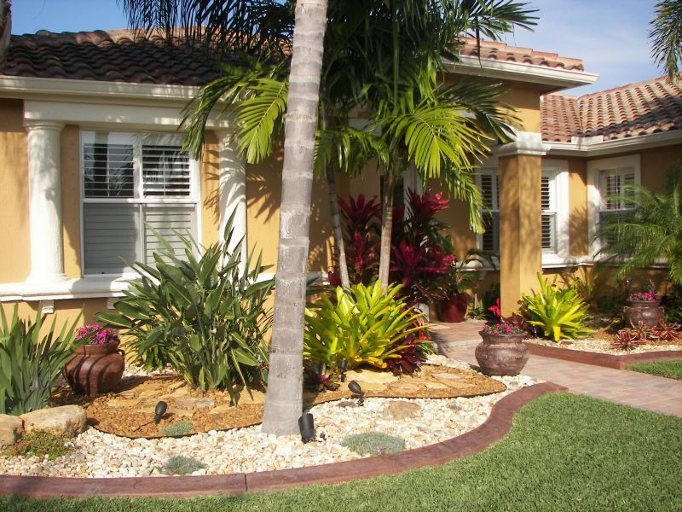

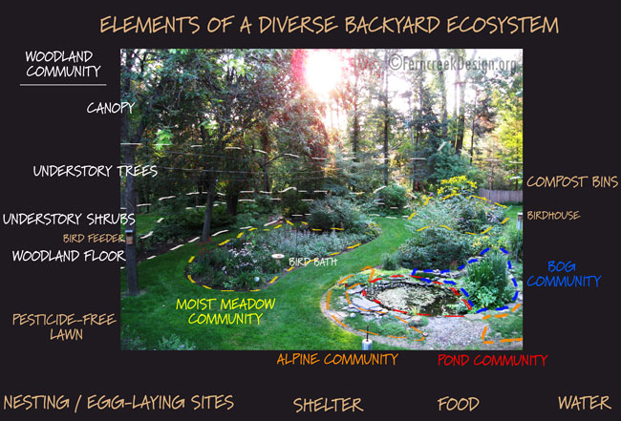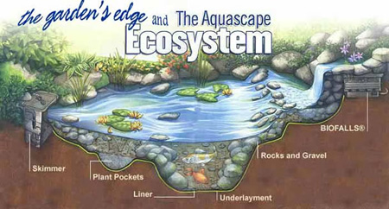

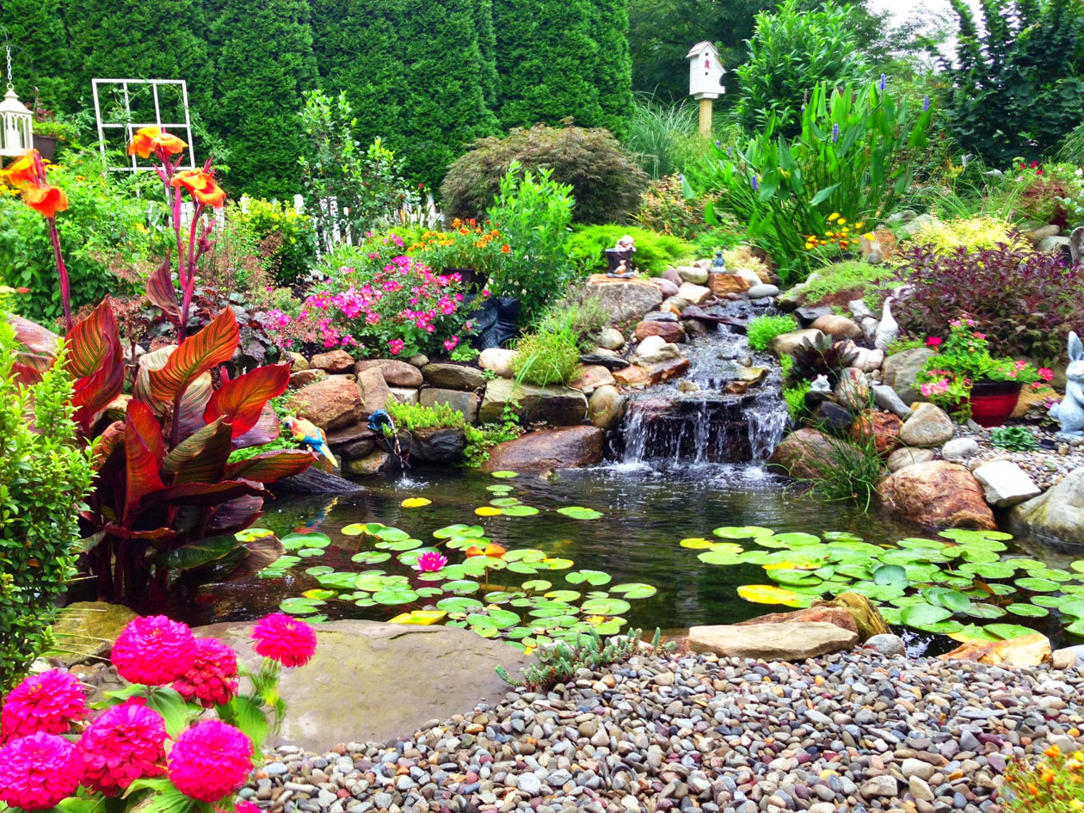

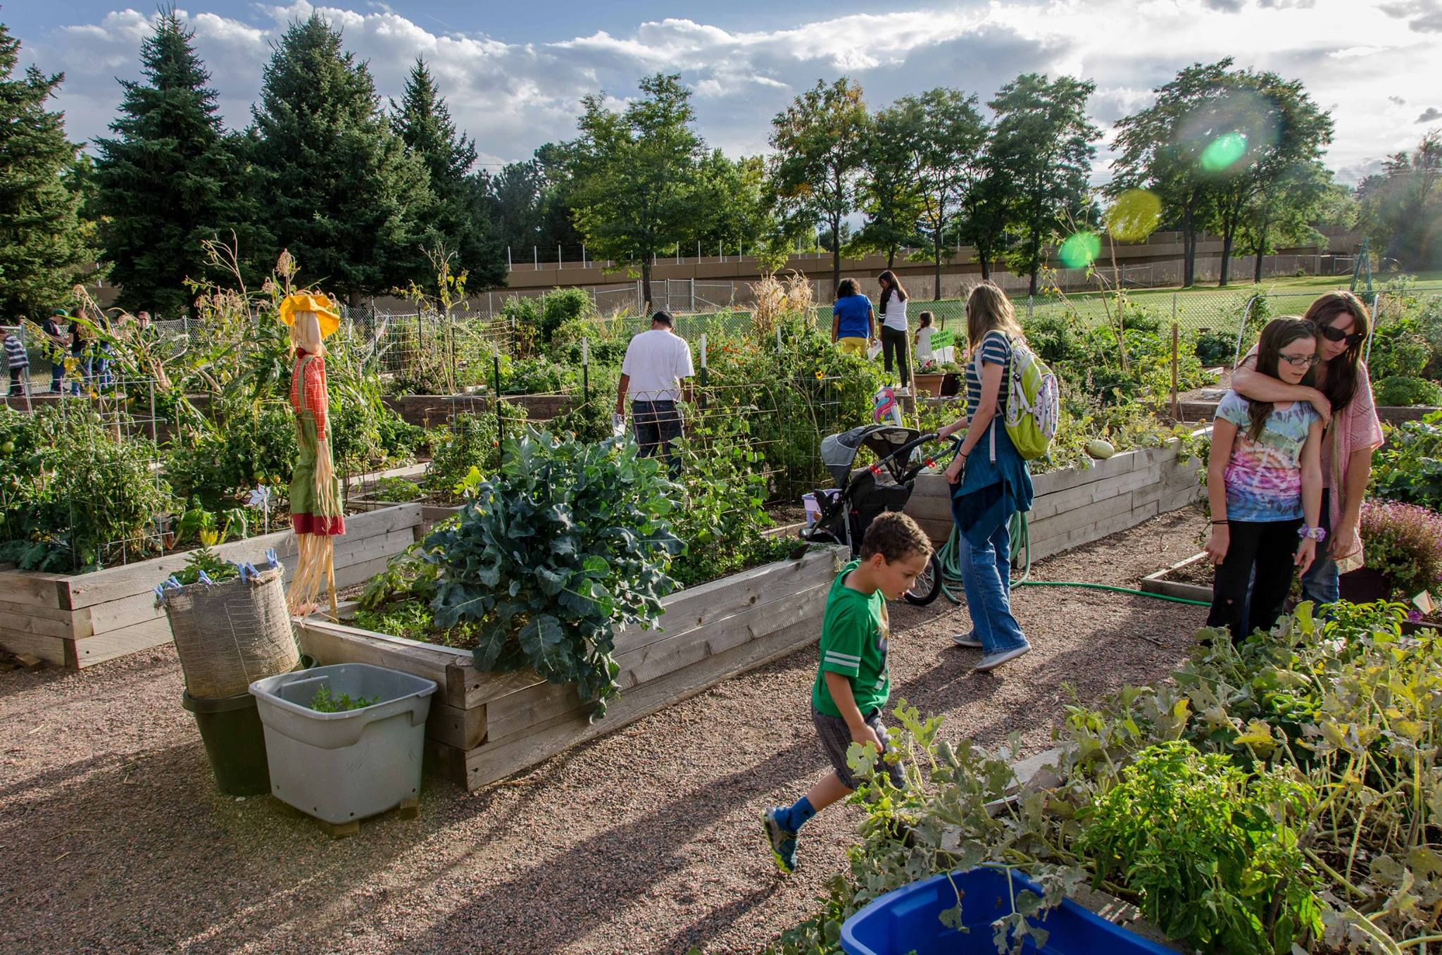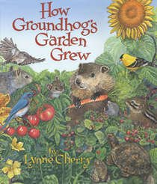

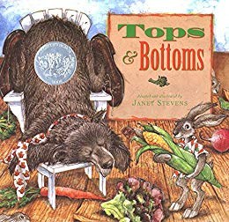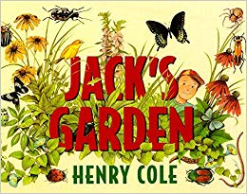

Websites:

- http://www.ecosystemgardening.com/ecosystem-gardening-defining-the-ecosystem.html
- https://pklifescience.com/article/404/garden-ecosystemlogin?username=thealberta&password=library (articles about gardens for kids)
- https://www.ogmlandscape.com/the-4-1-1-on-florida-xeriscaping/
- https://www.floridatoday.com/story/life/home-garden/2014/05/16/5-things-best-native-florida-plants-to-use-for-xeriscaping/9175767/
- https://www.slideshare.net/Eric851q/a2x576
- https://www.youtube.com/watch?v=JPHqUxxyLsY (ecosystem video)
- https://www.pbs.org/parents/thrive/best-gardening-books-for-kids
- https://kidsgardening.org/
- https://modelelicitingactivities.weebly.com/jacks-garden.html

Standards

K
SC.K.L.14.1 Recognize the five senses and related body parts.
SC.K.L.14.2 Recognize that some books and other media portray animals and plants with characteristics and behaviors they do not have in real life.
SC.K.L.14.3 Observe plants and animals, describe how they are alike and how they are different in the way they look and in the things they do.
1st

SC.1.L.14.1 Make observations of living things and their environment using the five senses.
SC.1.L.14.2 Identify the major parts of plants, including stem, roots, leaves, and flowers.

SC.1.L.14.3 Differentiate between living and nonliving things.

SC.1.L.16.1 Make observations that plants and animals closely resemble their parents, but variations exist among individuals within a population.
SC.1.L.17.1 Through observation, recognize that all plants and animals, including humans, need the basic necessities of air, water, food, and space.

SC.1.E.6.1 Recognize that water, rocks, soil, and living organisms are found on Earth's surface.
SC.1.E.6.2 Describe the need for water and how to be safe around water.
SC.1.E.6.3 Recognize that some things in the world around us happen fast and some happen slowly.

2nd

SC.2.L.16.1 Observe and describe major stages in the life cycles of plants and animals, including beans and butterflies.
SC.2.L.17.1 Compare and contrast the basic needs that all living things, including humans, have for survival.
SC.2.L.17.2 Recognize and explain that living things are found all over Earth, but each is only able to live in habitats that meet its basic needs.

SC.2.E.6.1 Recognize that Earth is made up of rocks. Rocks come in many sizes and shapes.
SC.2.E.6.2 Describe how small pieces of rock and dead plant and animal parts can be the basis of soil and explain the process by which soil is formed.

SC.2.E.6.3 Classify soil types based on color, texture (size of particles), the ability to retain water, and the ability to support the growth of plants.
3rd

SC.3.L.14.1 Describe structures in plants and their roles in food production, support, water and nutrient transport, and reproduction.
SC.3.L.14.2 Investigate and describe how plants respond to stimuli (heat, light, gravity), such as the way plant stems grow toward light and their roots grow downward in response to gravity.
SC.3.L.15.1 Classify animals into major groups (mammals, birds, reptiles, amphibians, fish, arthropods, vertebrates and invertebrates, those having live births and those which lay eggs) according to their physical characteristics and behaviors.

SC.3.L.15.2 Classify flowering and nonflowering plants into major groups such as those that produce seeds, or those like ferns and mosses that produce spores, according to their physical characteristics.
SC.3.L.17.1 Describe how animals and plants respond to changing seasons.

SC.3.L.17.2 Recognize that plants use energy from the Sun, air, and water to make their own food.
4th

SC.4.L.16.1 Identify processes of sexual reproduction in flowering plants, including pollination, fertilization (seed production), seed dispersal, and germination.
SC.4.L.16.2 Explain that although characteristics of plants and animals are inherited, some characteristics can be affected by the environment.
SC.4.L.16.3 Recognize that animal behaviors may be shaped by heredity and learning.

SC.4.L.16.4 Compare and contrast the major stages in the life cycles of Florida plants and animals, such as those that undergo incomplete and complete metamorphosis, and flowering and nonflowering seed-bearing plants.
SC.4.L.17.1 Compare and contrast the major stages in the life cycles of Florida plants and animals, such as those that undergo incomplete and complete metamorphosis, and flowering and nonflowering seed-bearing plants.
SC.4.L.17.2 Explain that animals, including humans, cannot make their own food and that when animals eat plants or other animals, the energy stored in the food source is passed to them.
SC.4.L.17.3 Trace the flow of energy from the Sun as it is transferred along the food chain through the producers to the consumers.
SC.4.L.17.3 Recognize ways plants and animals, including humans, can impact the environment.
SC.4.E.6.3 Recognize that humans need resources found on Earth and that these are either renewable or nonrenewable.
SC.4.E.6.6 Identify resources available in Florida (water, phosphate, oil, limestone, silicon, wind, and solar energy).
5th

SC.5.L.14.2 Compare and contrast the function of organs and other physical structures of plants and animals, including humans, for example: some animals have skeletons for support -- some with internal skeletons others with exoskeletons -- while some plants have stems for support.

SC.5.L.15.1 Describe how, when the environment changes, differences between individuals allow some plants and animals to survive and reproduce while others die or move to new locations.

SC.5.L.17.1 Compare and contrast adaptations displayed by animals and plants that enable them to survive in different environments such as life cycles variations, animal behaviors and physical characteristics.

