What Energy Source Would the Lorax Choose?
Discuss:
What type of energy do we use to power our homes and our school?
How the electricity we use is made?
Are there any problems with the way we make electricity?
Why do grown-ups tell kids “Don’t waste electricity, turn off the lights and T.V. when you are not using them and close the door.”?
How do we get energy? What do we have to trade for energy? (Discuss how buyers and sellers interact to exchange money for energy).

- Summative Assessment
Letters to the More Than Once-ler will be used to assess.
- Prior Knowledge
Discuss that people use electricity or other forms of energy to cook their food, cool or warm their homes, and power their cars.
- Supplemental Reading
Elementary Energy Infobook www.need.org/curriculum
- Guiding/reflective Questions
What are some examples of how we use energy?
What are some types of energy we use?
Where does the energy we use come from?
What are some basic forms of energy?
Where can light energy come from? What can it do?
Where can heat energy come from? What can it do?
Where can sound energy come from? What can it do?
Where can electrical energy come from? What can it do?
Where can mechanical energy come from? What can it do?
The Lorax (Shared reading with students or video) https://www.youtube.com/watch?time_continue=2&v=8V06ZOQuo0k
Reading Letter Passage 1
Readiness Questions
What were the wants of the Lorax? Did he want goods or services?
What criteria did the Lorax mention?
Data Set 1
Comprehension/readiness questions
Which resources are scarce? Scarce resources are non-renewable. Which energy sources are scarce?
What are the costs of the different energy choices?
What are the benefits of the choices?
Which decision would you make based on the criteria mentioned by the Lorax?
Based on your research, are there any other things you would recommend to The Lorax?
Letter Template 1
Reading Letter Passage 2
Nuclear Energy reading passage
Data Set 2
Letter Template 2
Reflection question 2
Why do you think they decided not to use some of the energy sources that were eliminated? (Discuss scarce resources).
What are the costs of the choices? What are the benefits of the choices?
Which decision would you make based on the criteria mentioned by The Lorax?
Based on your research, are there any other things you would recommend to The Lorax?
What type(s) of energy can the More Than Once-ler consider using while staying within their $700,000 budget? Answer: Solar, Wind, Hydro, and Nuclear.
What type(s) of energy exceeds the $700,000 budget? Answer: Natural Gas.
What is the problem? Answer: The More Than Once-ler needs to know what type of energy would be best for the new factory.
Who is the client? Answer: The More Than Once-ler
What is the client asking your team to do? Answer:
What things do you need to include in your solution? Answer: A ranking of energy type suggestions and the procedure used to get those rankings.
Do you think there is more than one correct answer to what the client is asking? Why or why not? Answer: Yes, because it is based on student priority interpretation.

Reading Passage 1
Sustainable Thneeds Inc.
2015 Solution Way
Cleanville, FL 36498

Dear Students,

My name is The More Than Once-ler and I am the new Sustainability Manager of Sustainable Thneeds Inc., a manufacturing company in Florida. We are building a new factory in Florida and need to decide which type of energy to use to power it. The kids in the local community want us to use a form of energy that will protect Florida’s environment so that they will have a clean and safe place to live when they grow up.
We need to know what type of energy you would suggest that our developers use in our new factory. We have given you an energy chart to help you make your decision.
Please write us back on the attached template, including how you arrived at your decision. Thank you for your assistance with this project!

Regards,
The More Than Once-ler
Sustainable Thneeds Inc.

Data Table 1
Energy Source | What is it? | Renewable or nonrenewable? | What problems does it cause?
Biomass | Biomass is anything that is alive. It is also anything that was alive a short time ago. Trees, crops, garbage, and animal waste are all biomass. Most of the biomass we use for energy today is wood. We burn wood to make heat. | Biomass energy is renewable, which means more biomass can be made in a short time. We can always grow more plants. | Burning biomass doesn’t cause as much pollution as burning coal. But many people don’t like to burn waste near their towns. Sometimes it smells bad. Waste-to-energy  plants work to scrub the air from the burning waste to reduce pollution and smells.
Coal | Coal looks like shiny, black rock. Coal has lots of energy in it. When it is burned, it makes heat and light energy. | The coal we use today took millions of years to form. We can’t make more in a short time. That  is why it is called nonrenewable. | Most coal is buried under the ground. We must dig it out—mine it. Mining can damage land because often all of the trees are cut down and the ground is dug up. When coal is burned, it can pollute the air.
Petroleum | Petroleum is a liquid that is found underground. Sometimes we call it oil.  Oil can be as thick and black as tar or as thin as water. Petroleum has a lot of energy. We can turn it into different fuels—like gasoline, kerosene, and heating oil. Most plastics and inks are made from petroleum, too. | The petroleum we use today was made hundreds of millions of years ago. We can’t make more  in a short time. That’s why we call petroleum nonrenewable. | Petroleum can damage our environment. Burning fuels made from oil can pollute the air.  Pollution from cars is a big problem in many parts of the country.  Oil can pollute soil and water, harming the animals that live in the area.
Natural gas | Natural gas is similar to air—it is a mixture of gases you can’t see, smell, or taste. But it is different, too. It has a lot of energy in it. You can burn it to make heat. Natural gas is found underground in pockets of rock. We drill wells into the ground to reach the gas so that it can flow to the surface. | The natural gas we use today took hundreds of millions of years to form. That’s why we call it a  nonrenewable energy source. We can’t make more in a short time. | Natural gas is the cleanest burning fossil fuel. It doesn’t pollute the air as much as coal or oil.
solar | Energy we get from the sun is called solar energy. It travels from the sun to the Earth in rays. Some are light rays that we can see. The sun is a star. It is a giant ball of gas. It sends out huge amounts of energy in the form of light and heat every day. | Solar energy is free and clean. There is enough for everyone, and we will never run out of it.  Solar energy is renewable. The sun will keep making energy for a very long time. | The hard part is capturing the sunlight. It shines all over the Earth and only a little bit reaches any one place. On a cloudy day, most of the light never reaches the ground at all.
wind | Wind is moving air. | As long as the sun shines, there will be winds on the Earth. We will never run out of wind energy. It is a renewable energy source. | Some people don’t like the way wind turbines look. Sometimes birds crash into them and become injured.
Hydropower | Hydro comes from the Greek word meaning water. Hydropower is the energy we make with moving water. Moving water has a lot of energy. We use that energy to make electricity. | Hydropower a renewable energy source. It does not create pollution and is cheap. | When dams are built to make hydropower, the reservoirs flood a lot of land. They change the flow of the rivers. Sometimes, fish can’t swim up the rivers and lay their eggs like they could before.

Letter Template 1
Dear The More Than Once-ler,
Our team has reviewed all of the data that you provided and are suggesting the following types of energy for Sustainable Thneeds Inc. We have ranked the types of energy in order beginning with our top choice.

Top Choice of Energy:

Alternate Choice #1: Alternate Choice #2:

Alternate Choice #3: Alternate Choice #4:

The evidence we used to make our choice was:

Our step-by-step procedure for selecting our top choice of energy was:

Thank you for the opportunity to assist you with this project!
Sincerely,

Reading Passage 2
Sustainable Thneeds Inc.
2015 Solution Way
Cleanville, FL 36498

Dear Students,

Thank you for your recommendations.
We have eliminated some of the nonrenewable sources of energy based on recommendations from you and other kids. We added nuclear power because it is very cheap. Please find out more about nuclear power by reading the article we have sent to you and consider it as an option too.
We need to use a type of energy you would that does not cost too much. We have given you an energy cost chart to help you make your decision. This chart shows how much it would cost to build the components we need to produce each type of energy.
Our company cannot exceed the $700,000 budget for energy use.
Please write us back on the attached template, including how you arrived at your decision. Thank you for your assistance with this project!

Regards,
The More Than Once-ler
Sustainable Thneeds Inc.

Uranium (Nuclear Energy)

Uranium is a mineral found in rocks in the ground. Uranium is nonrenewable. We can’t make more. There is plenty of uranium in many parts of the world. We split uranium atoms to release energy. There is energy stored in the nucleus of an atom. It is called nuclear energy. It holds the atom together. To use this energy, we have to set it free. To free the energy in atoms is to split them apart. We can split one atom into two smaller atoms. This is called fission. The two smaller atoms don’t need all the energy that held the larger atom together. The extra energy is released as heat and radiation.
Nuclear power plants use fission to make electricity. Atoms of uranium are split into two smaller atoms. The extra energy is released as heat. This heat is used to make electricity. Nuclear power is clean since no fuel is burned to pollute the air. And uranium is a cheap fuel. Right now, about 19 percent of our electricity comes from splitting atoms of uranium in nuclear power plants.
During fission, heat isn’t the only energy that is released. Rays of energy, like x-rays, are also given off. These rays of energy, called radiation, can be dangerous in large amounts. Large amounts of radiation can kill our cells and poison our food and water.
The fuel from nuclear power plants produces radiation for a long time. After the fuel is used, it still is radioactive—it gives off radiation. It can’t be put into a landfill. It must be carefully stored. Some people don’t think we should use nuclear energy. They think the radiation is too dangerous. Other people think nuclear energy is a clean, safe way to make electricity.

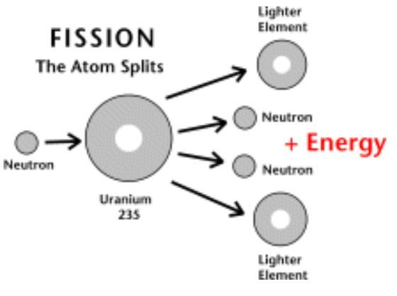

Data Set 2
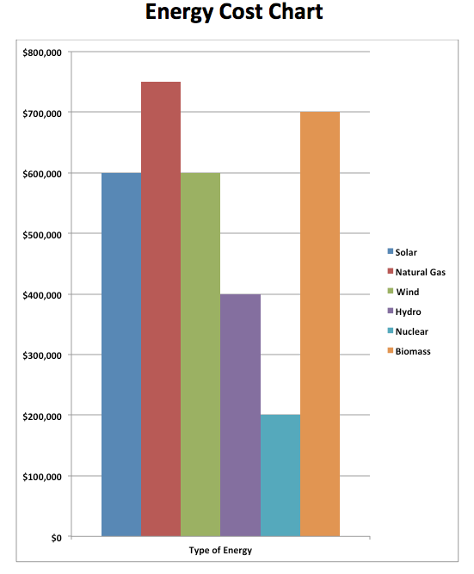

Letter Template 2
Dear More Than Once-ler,

Our team has reviewed all of the data that you provided and are suggesting the following types of energy for Sustainable Thneeds Inc. We have ranked the types of energy in order beginning with our top choice.

Top Choice of Energy:

Alternate Choice #1: Alternate Choice #2:

Alternate Choice #3: Alternate Choice #4:

The evidence we used to make our choice was:

Our step-by-step procedure for selecting our top choice of energy was:

Thank you for the opportunity to assist you with this project!
Sincerely,

