Where should recycling bins be placed?

For this decision-making lesson, students will discuss criteria for choosing where to place a new recycling bin at Landmark Cinema using photographs and Internet resources. Using this information, students will rank their choices and explain how they reached those decisions.

Problem
Where should the new recycling bin be placed?

Alternatives
Near vending machines, in the employee parking lot, at the outdoor break area, outside the back door, by the street entrance.

Criteria
Easy to get to, near where employees might have food or drinks, opportunity for other community members to use the bin, many people pass by it.

Decision
Should the new recycling bin go by vending machines, the employee parking lot, the outdoor break area, outside the back door, or near the street entrance?

- Introduce the idea of people show good citizenship by helping in the community. What are ways that people help out in their community?
  - What goods and services do people provide in their community?
  - Ask students about buyers and sellers. Who are the buyers? Who are the sellers in these texts?
- Read the letter from Landmark Cinema (Page 5) What is the problem?
- Using the letter, identify the alternatives and criteria related to choosing the best place for a new recycling bin.
- View the text about the five best places to put outdoor recycling bins:
  - https://www.wastewiseproductsinc.com/blog/workplace/the-5-best-places-to-put-outdoor-recycling-bins/
  - While you read the text together, students can use the optional Note-taking tool (Page 6).
- Use the images (Pages 3-4) to analyze each alternative. Provide the students with the Decision-making Table (Page 7). Start with the image of the vending machines:
  - What would make this place a good spot for a recycling bin? Is it easy to get to? Would employees have food or drinks here? Is there an opportunity for other community members to use the bin? Do many people pass by it?
    - Teachers may choose to display all locations and discuss one criterion at a time.
  - Discuss each criterion related to each location.
- Discuss the vending machine location. What are good reasons to choose this spot? What are some reasons that this might not be the best choice?
- Repeat this process for the other locations.
- Students work in groups to discuss the criteria and rank their choices from highest to lowest.
- Share results. Discuss opportunity cost (the next best choice that was given up). Make the connection between their second choice as the opportunity cost.
- Ask students to talk about the processes of making their best choices. What did they do first? After that?
- Students write a letter to Landmark Cinema explaining how they made their choices. A frame can also be used

Extension/ideas:
- After groups rank their choices, suggest other criteria that could change their decisions:
- Have students research recycling in their school and home communities.
- Read the following ReadWorks texts:
  - How Plastic is Recycled https://www.readworks.org/article/How-Plastic-Is-Recycled/9eacd0ec-5f34-4ada-8a33-2c9e0a835655#!articleTab:content/
  - Take Care of our Planet https://www.readworks.org/article/Take-Care-of-Our-Planet/e24b98a5-0368-4654-8fb8-07b2119cf0cb#!articleTab:content/

Differentiation:
- Reduce alternatives and/or criteria.
- Increase alternatives and/or criteria.
- Increase the number of pictures related to the alternatives and/or criteria.

Images to use with students for the lesson:

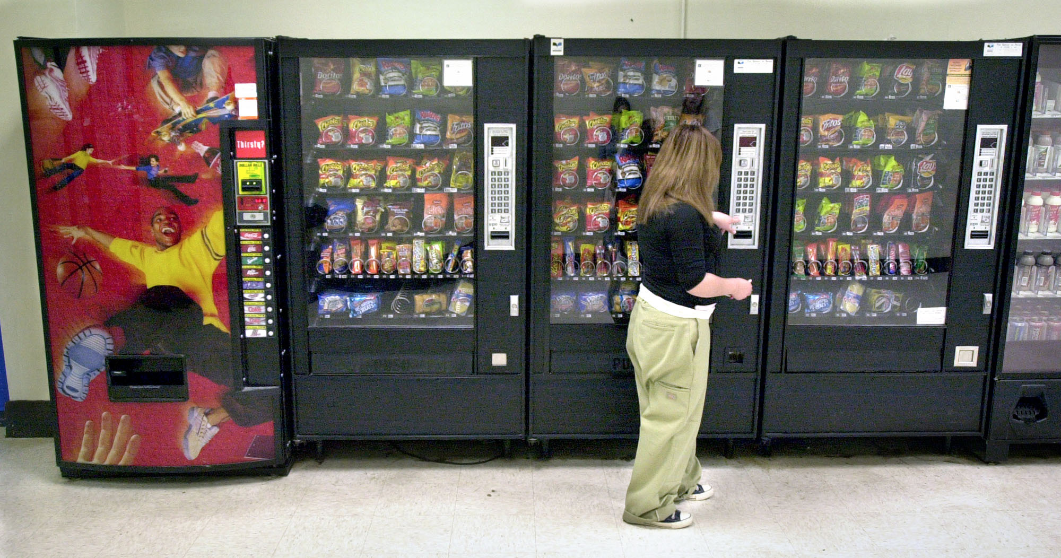

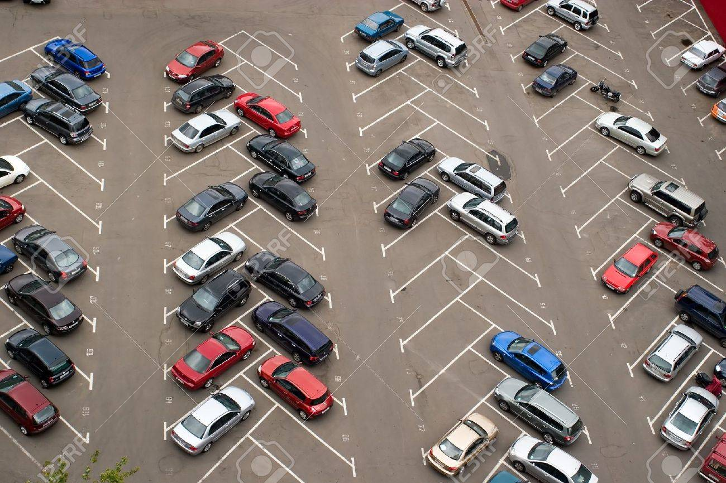

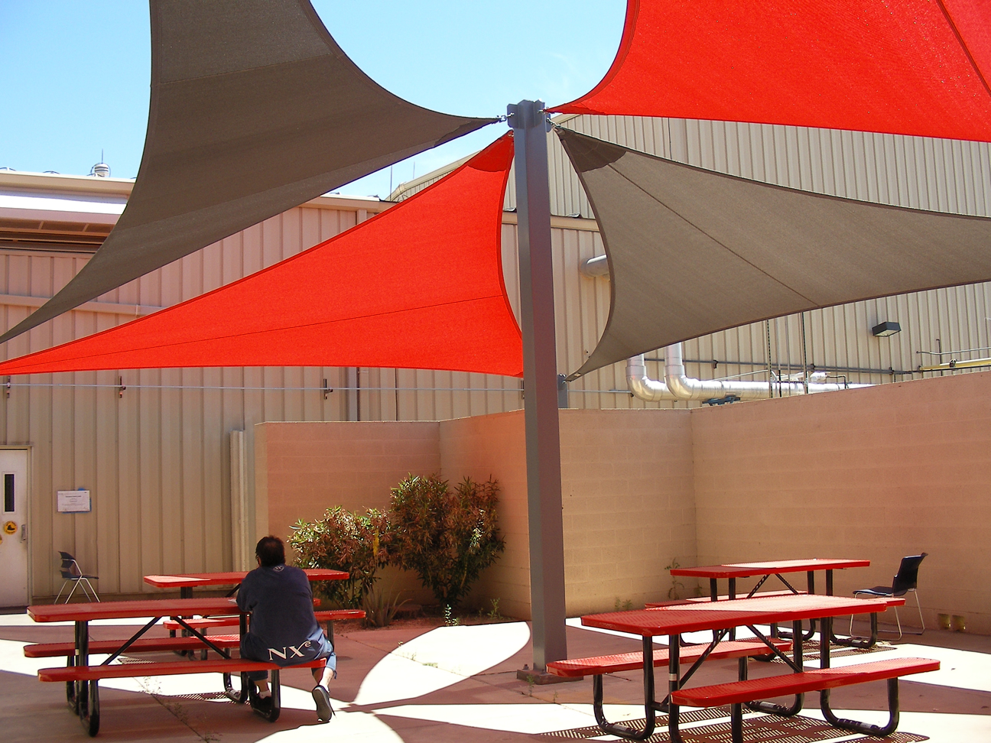

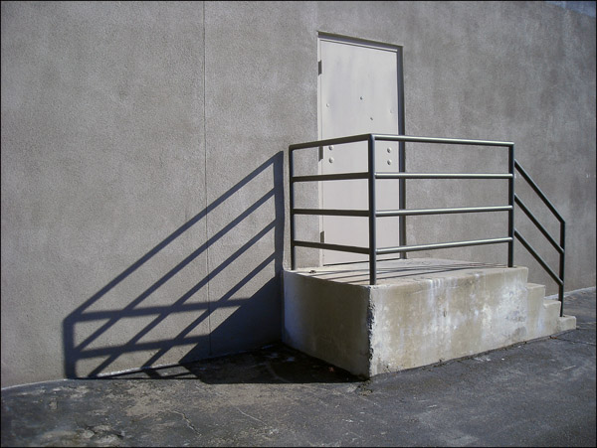

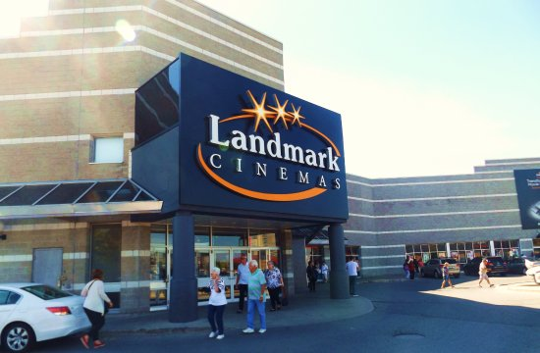

Letter/Proposal

Dear Students,

Landmark Cinemas is dedicated to helping our community stay beautiful. We are pleased to announce that we are expanding our recycling efforts to include our new theater in your area.

While we are very excited to get this project started, we need some help in deciding where to put our new recycling bin. Our employees made the following suggestions:

- Near vending machines
- In the employee parking lot
- At the outdoor break area
- Outside the back door
- By the main street entrance

Additionally, there are some other considerations:

- It should be easy to get to.
- It should be near where employees might have food or drinks.
- There should be an opportunity for other community members to use the bin.
- Many people should pass by it.

Please review the five locations and decide which place is best for our new recycling bin. We thank you for your help in helping us keep our city clean!

Landmark Cinema

Note-taking tool: Note-taking tool. Use the article: https://www.wastewiseproductsinc.com/blog/workplace/the-5-best-places-to-put-outdoor-recycling-bins/ and take notes about the different locations.

Near vending machines
In employee parking lot
At the outdoor break area
Outside the back door
By the main entrance

Decision-making Table

 | Criteria: Why are some locations good for recycling bins?
Alternatives: Different Locations | Easy to get to | Near where employees might have food or drinks | Opportunity for other community members to use the bin | Many people pass by it.
Near vending machines
In employee parking lot
At the outdoor break area
Outside the back door
By the main entrance

Frame for answering the letter/proposal:

Dear ______________,

Here is how we ranked each location for a recycling bin:

#1 ____________________
#2 ____________________
#3 ____________________
#4 ____________________
#5 ____________________

We think you should put your new recycling bin ________________. We based our decision on the following criteria: ___________________________________,
________________________________________________________________,
and _____________________________________________________________.
This recycling location is the best choice because _________________________
_________________________________________________________________.

Thank you,

Social Studies Standards:
SS.E.1 Basic Economics
SS.C.2 Civic responsibility

Economic concepts for review:
Opportunity cost – The second best choice
Goods – Something that you use
Services – Something that someone does for you
Buyers – People who buy goods or services
Sellers – People who sell goods or services
Producers – People who create and supply goods or services

English/Language Arts Standards:
LAFS.RI.1.1 Ask and answer questions about key details in a text.
LAFS.RI.3.7 Use illustrations and details in a text to describe its key details.
LAFS.W.3.8 With guidance and support from adults, recall information from experiences or gather information from provided sources to answer a question.
LAFS.SL.1.1 Participate in collaborative conversations with diverse partners about grade 1 topics and texts with peers and adults in small and larger groups.
a. Follow agreed-upon rules for discussions (e.g., listening to others with care, speaking one at a time about the topics and texts under discussion).
b. Build on others’ talk in conversations by responding to the comments of others through multiple exchanges.
c. Ask questions to clear up any confusion about the topics and texts under discussion.

Science
Big Idea 17 SC.1.L.17 : Interdependence

